Co-curricular activities conducted by the College

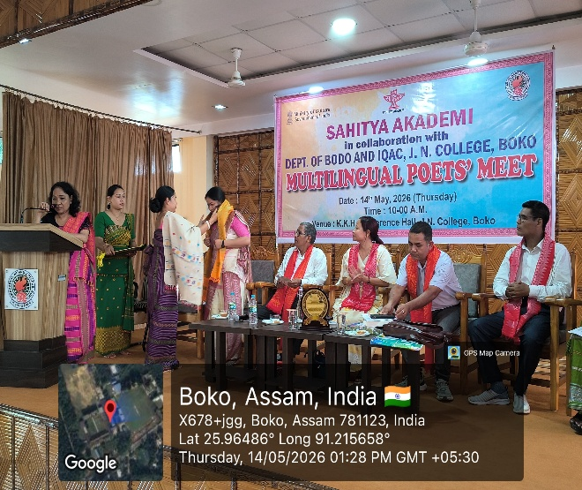
- Seminar on Bal Sahiti organised by Sahitya Akademi in collaboration with Dept. of Bodo and IQAC, J.N. College, Boko.
